Lab 1 – Setting Up Flutter and Running Your First App
1. Objective
This lab helps students set up the Flutter environment and run their first Flutter application. Students will learn how to install tools, create a project, execute it on a device/emulator, and perform basic UI customization.
2. Requirements
Students must:
- Install Flutter SDK
- Configure IDE (Android Studio or VS Code)
- Create and run a Flutter app
- Customize the layout
- Submit screenshots as evidence
3. Guided Steps
Exercise 1 – Flutter Environment Setup
Goal: Install and verify Flutter tools.
Steps
- Install Flutter SDK.
- Add Flutter to PATH.
- Run:
flutter doctor
- Ensure all items are properly configured.
- Verify Flutter & Dart plugins in Android Studio.
Deliverables
- Screenshot of flutter doctor
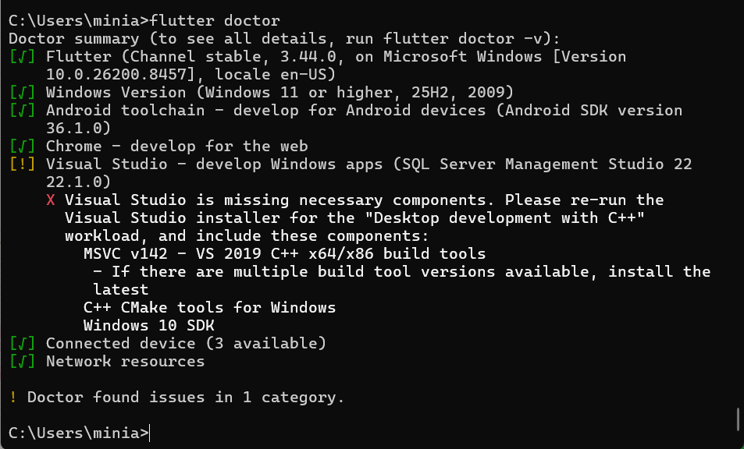
- Screenshot of Flutter/Dart plugin screen
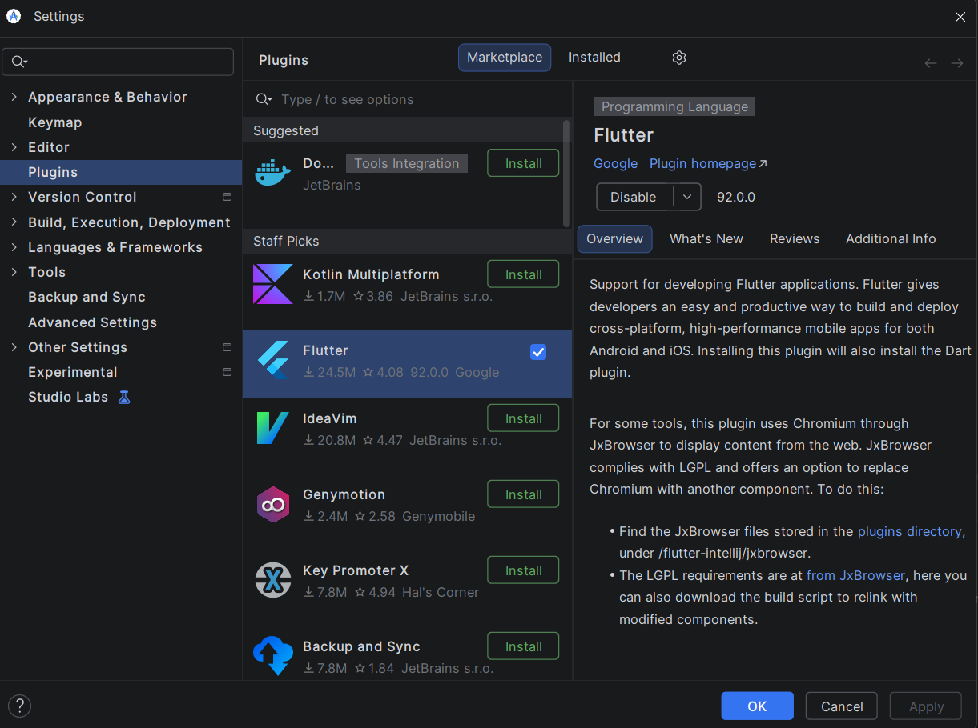
Exercise 2 – Create and Run Your First Flutter App
Goal: Learn how to create a Flutter project and run the default app.
Steps
- Open Android Studio → New Flutter Project
- Use project name: hello_flutter_lab1
- Explore key folders: lib/, android/, ios/, pubspec.yaml
- Start emulator or connect device
- Run the default counter app
- Modify the AppBar title in main.dart:
title: 'My First Flutter App',
- Use Hot Reload and observe changes
Deliverables
- Screenshot of project structure
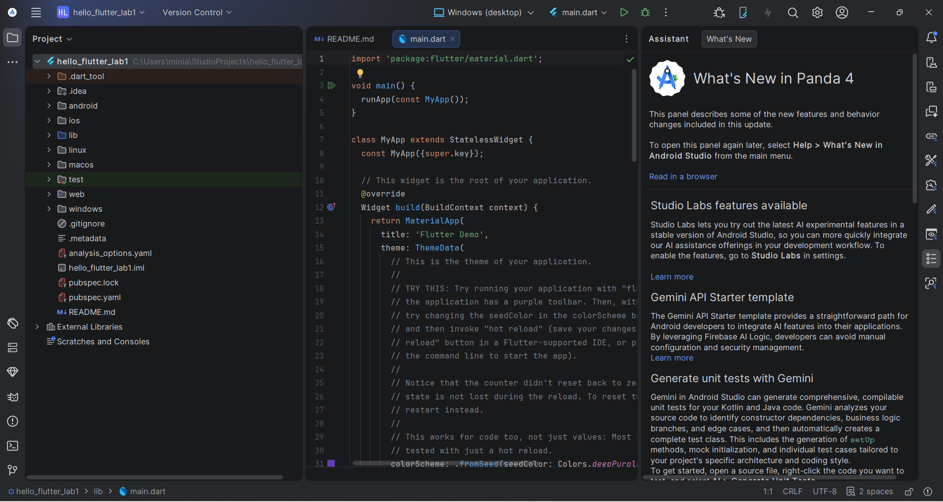
- Screenshot of running counter app
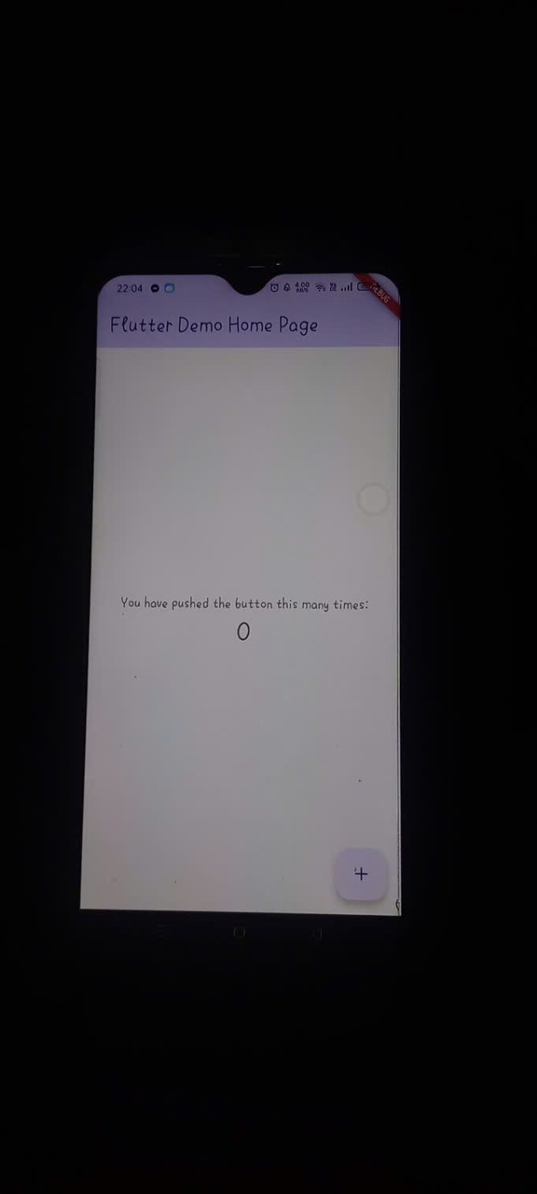
- Screenshot showing updated title via Hot Reload
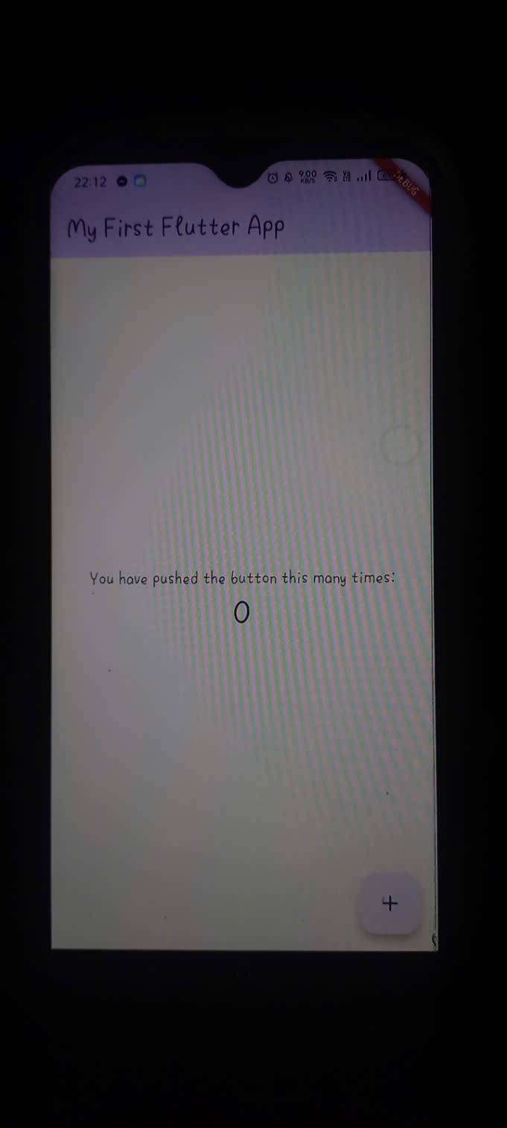

Exercise 3 – Customize Your First Flutter UI
Goal: Build a simple custom UI with widgets learned in class.
Steps
- Replace default code in main.dart with:
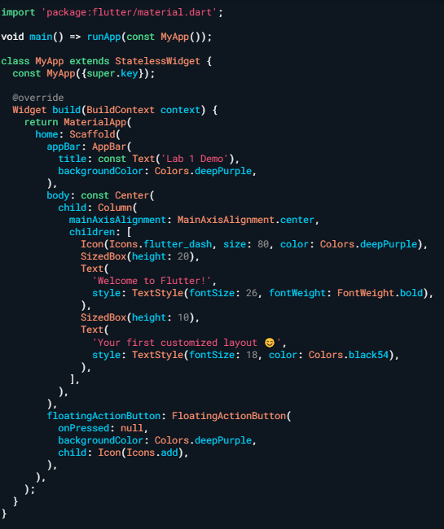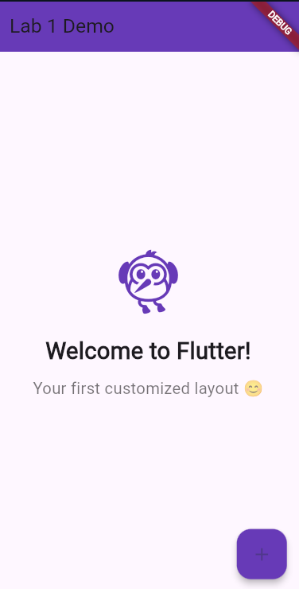

- Perform Hot Reload and verify UI updates.
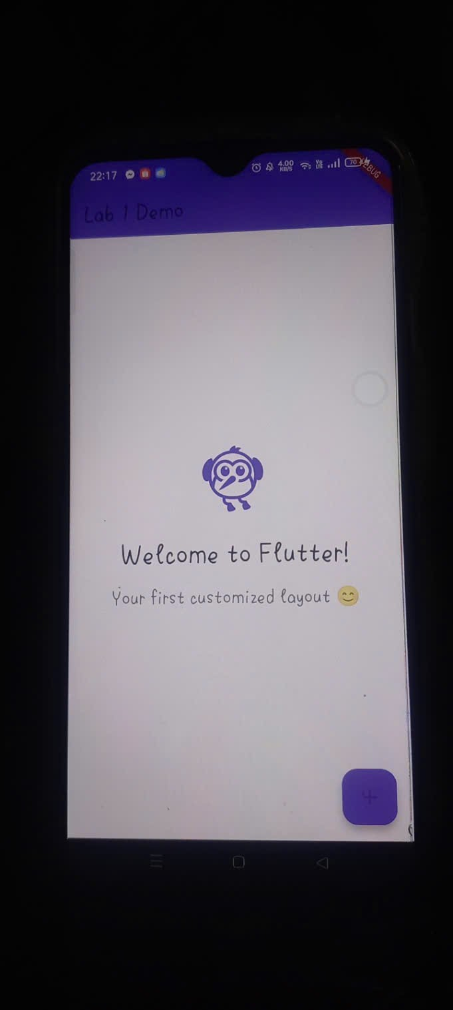
- Modify colors/text and reload again.
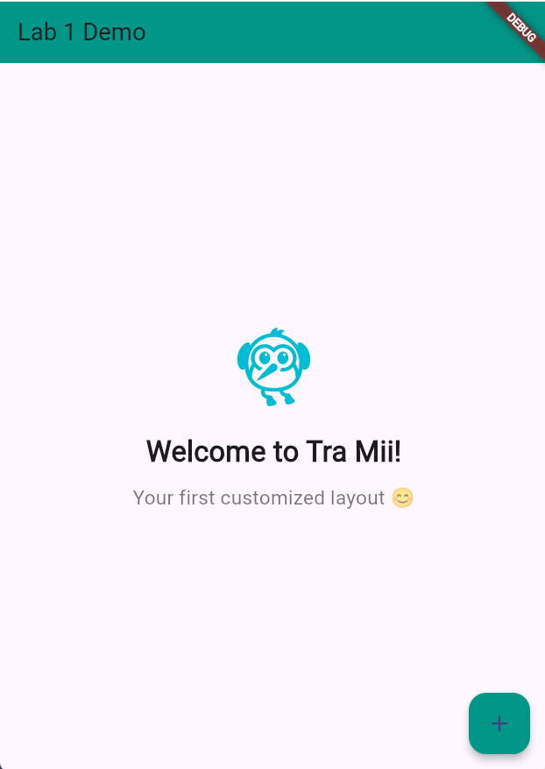
Exercise 4 – Reflection Questions
- What is the purpose of the flutter doctor command?
The flutterdoll command is used to check the Flutter development environment on a computer. It scans the entire system to see if the necessary tools (such as the Flutter SDK, Android Studio, connected devices, etc.) are installed and configured correctly, and provides warnings or troubleshooting instructions if any are missing.
- What file acts as the entry point of a Flutter application?
The starting point of every Flutter application is the lib/main.dart file. More specifically, the program will always begin running from the main() function defined inside this file.
- Explain the difference between Hot Reload and Hot Restart.
Hot Reload: Updates only minor UI or logic changes to the running application extremely quickly (usually under 1 second) without losing the application's current state.
Hot Restart: Reloads the entire source code and restarts the application from scratch. This process takes a little longer and refreshes the application's state to its initial state.
- How does runApp() build the widget tree?
The runApp() function takes a specific widget as input (usually an application-wide widget like MaterialApp or MyApp). It then makes this widget the root widget of the widget tree and draws it across the entire device screen.
- Describe how Flutter’s architecture enables cross-platform development.
Unlike many other frameworks that rely on native interface components (OEM widgets) for each operating system, Flutter draws everything on the screen itself. Flutter uses the Dart language and has its own graphics rendering engine (formerly Skia, now Impeller). By controlling the entire interface drawing process on a blank canvas, Flutter ensures that applications can compile from a single source code and run with consistent interface and performance across Android, iOS, Web, and Desktop.
4. Expected Results
- Successful setup of Flutter environment
- Ability to create and run Flutter projects
- Understanding of widgets, layout, and hot reload
- Complete screenshots for all required steps

5. Submission
- Zipped Flutter project folder or GitHub link
- All screenshots
- Written answers for reflection questions

